**What is difference between Test Cases vs Test Scenarios?**

Software testing field is very much interesting field to work on, however sometimes many testers were get confused in common software terminologies. Few days back one of colleague was taking interview of Software tester of 2 years experience. In the interview he asked one question “[**What is difference between Test Case and Test Scenarios**](http://www.softwaretestingclass.com/what-is-difference-between-test-cases-vs-test-scenario/)” then that guy was confused on the answering the question and unable to answer question properly. So I thought to shed some light on basic software testing terminologies.

In today’s article we will talk about definitions of Test Case and Test Scenarios and we will see the basic differences between **Test Cases vs Test Scenarios**.

**Test Case is ‘How to be tested’ and Test Scenario is ‘What to be tested’**

So take a quick look at the **Definition of Test Cases and Test Scenarios:**

[**Test Case**](http://en.wikipedia.org/wiki/Test_case)**:** A test case is a set of conditions or variables under which a tester will determine whether an application, software system or one of its features is working as it was originally established for it to do.

**Test Scenario**: The exhaustive testing is not possible due to large number of data combinations and large number of possible paths in the software. **Scenario testing** is to make sure that end to end functionality of application under test is working as expected. Also check if the all business flows are working as expected. In scenario testing tester need to put his/her foot in the end users shoes to check and perform the action as how they are using application under test. In scenario testing the preparation of scenarios would be the most important part, to prepare the scenario tester needs to consult or take help from the client, stakeholder or developers.

[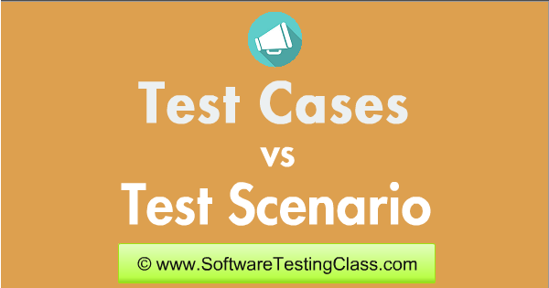](http://www.softwaretestingclass.com/wp-content/uploads/2014/10/Test-Cases-vs-Test-Scenarios.png)

**Difference between Test cases vs Test scenarios:**

|  |  |
| --- | --- |
| **Test Case** | **Test Scenario** |
| Test case consist of test case name, Precondition, steps / input condition, expected result. | Test scenario consists of a detailed test procedure. We can also say that a test scenario has many test cases associated with it. Before executing the test scenario we need to think of test cases for each scenario. |
| Test cases are low level actions and it can be derived from test scenarios. | Test scenarios are the high level classification of test requirement grouped depending on the functionality of a module and it can be derived from use cases. |
| Test case is give detailed information about if any pre-condition, what to test, how to test and expected result etc. | Test scenario is one liner statement which tell us about what to test. |
| Test case means detailed documenting the cases which help executing while testing. | Test Scenario means talking and thinking requirements in detail. |
| Test cases are set of steps which performed on system to verify the expected output. | Test scenario is thread of operations. |
| Test cases are more importance in case where development is happening onsite and QA is happening Off shored. It will help to understand and make both developer and QA in sync. | Test scenarios are more important when time to write test cases is no sufficient and team members are agree with the detailed one liner scenario. |
| Writing test cases is one time effort which can be used in future while executing regression test case. While reporting defects it will help tester to link the defect with test case id. | In new software testing generation it is new idea and time saver activity. The addition and modification (easy maintainability) of test scenarios is easy and independent on specific person. |
| The detailed test case document is full proof guard for new software tester. If developer missed something then it is easy to catch while executing these full-proof test cases. | One of the most positive point about test scenario is good test scenarios reduces the complexity and repeatability of product. |
| It requires more time and resources due to detailed test case which talks about how to test and what to test. | If the test scenario not detailed enough then it might take some time to discussion and understand what test scenario is exactly talking about. |

Here is quick example on how to write **Test Cases vs Test Scenarios:**

**Example 1)**

Requirement is to test your phone WiFi:

|  |  |
| --- | --- |
| Test Scenario | Verify that device automatically connects to Wi-Fi if user creates new profile |
| Test cases | Test case 1: Create WiFi profile and verify that it created successfully |
| Test case 2: Verify that device is able to connect to Wi-Fi |

**Example 2)**

Sample Requirement: Use case ID: UC0001 – Verify and validate the end to end functionality of e-commerce website. Only register customers should be login into site using valid credentials and place the order.

**Test Scenario:**

[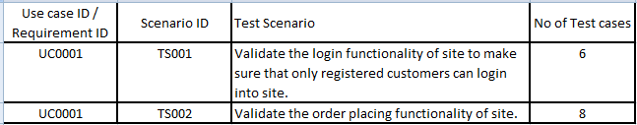](http://www.softwaretestingclass.com/wp-content/uploads/2014/10/Test-Cases-VS-Test-Scenario1.png)[*Click on the image to enlarge the image*]

**Test Cases:**

[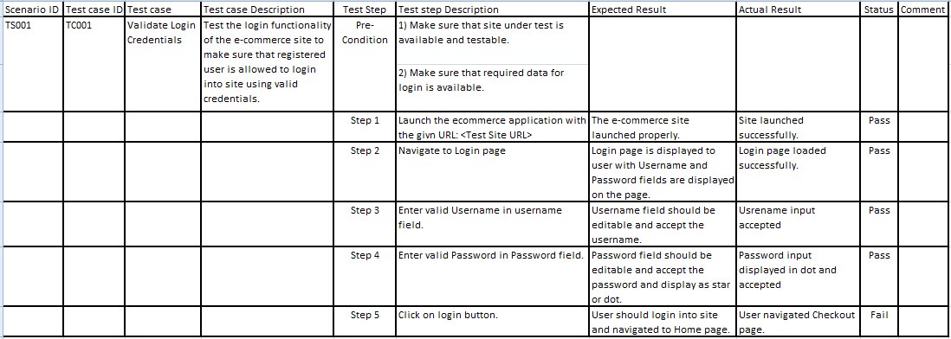](http://www.softwaretestingclass.com/wp-content/uploads/2014/10/Test-Cases-VS-Test-Scenario.png)

[*Click on the image to enlarge the image*]

Over to you, In today’s article we have seen about Test Cases and Test Scenario difference and it’s importance. Better understanding of this we have covered examples of *Test Cases Vs Test Scenarios*. If you have any questions in your mind then your questions and comments are always welcome. So let’s tell us our reader about more examples of test scenario and test cases in below comments.

s